Familiar and Unfamiliar Navigation using Proto.io

Aim
To create a mobile app prototype with familiar and unfamiliar navigation elements using Proto.io and evaluate ease of use among different user groups.

Tool Used
- Proto.io
- Web Browser

Description of Prototype
A shopping app prototype named Snapmart was created with two navigation styles:

1. Familiar Navigation
- Bottom navigation bar (Home, Search, Cart, Profile)
- Category buttons (Women, Men, Kids)
- Standard icons with labels
This design is commonly used in many apps, so users easily understand it.

2. Unfamiliar Navigation
- Circular (radial) menu in the center
- Icon-based navigation without text
- Voice navigation using microphone icon
This design is innovative but not commonly used.

User Groups
- Students (18–25 years)
- Working Professionals (26–40 years)
- Older Adults (40+ years)

Observation
- Familiar navigation was easy for all users.
- Unfamiliar navigation was easy for students but confusing for older adults.
- Familiar design had faster task completion and fewer errors.

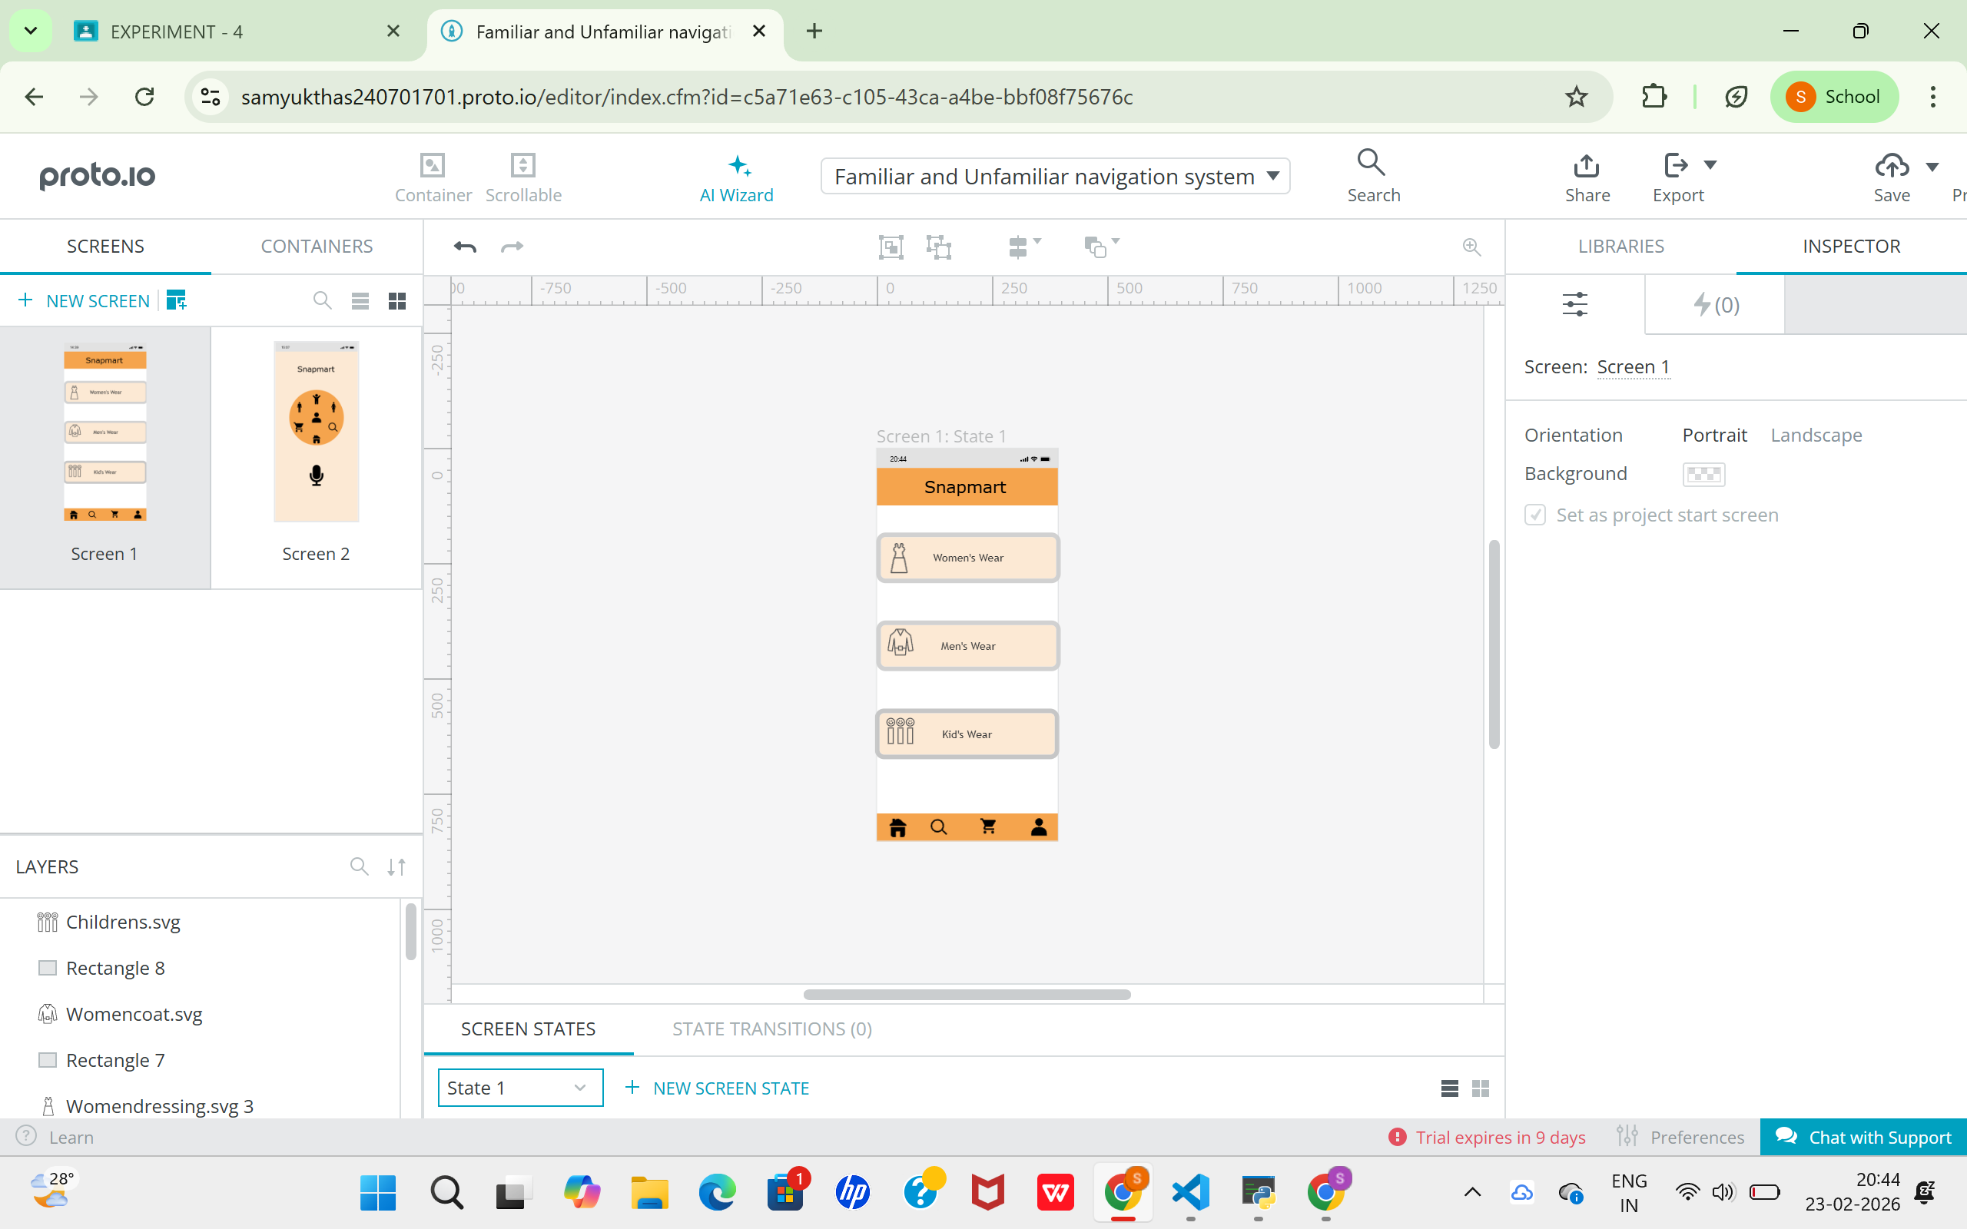
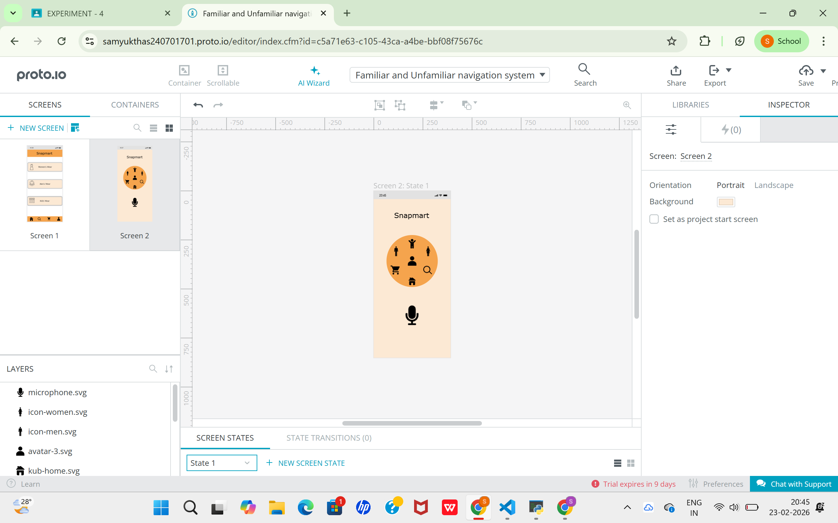

Result
Familiar navigation provides better usability and user satisfaction.
Unfamiliar navigation is creative but requires better guidance for users.

